**Practical No 10**

**Description:**

Automation Testing or Test Automation is a software testing technique that performs using special automated testing software tools to execute a test case suite. On the contrary, Manual Testing is performed by a human sitting in front of a computer carefully executing the test steps.

**Aim: To perform the test automation using selenium web drivers in java.**

**Theory:**

Selenium is a popular open-source web-based automation tool. Selenium WebDriver is a collection of open source APIs which are used to automate the testing of a web application. Selenium WebDriver tool is used to automate web application testing to verify that it works as expected. It supports many browsers such as Firefox, Chrome, IE, and Safari.

**Given below are the steps for Automation Testing using Selenium Web Drivers in Java:**

**Step 1: Install Java on your computer**

Download and install the Java Software Development Kit (JDK)

<https://www.oracle.com/technetwork/java/javase/downloads/index.html>

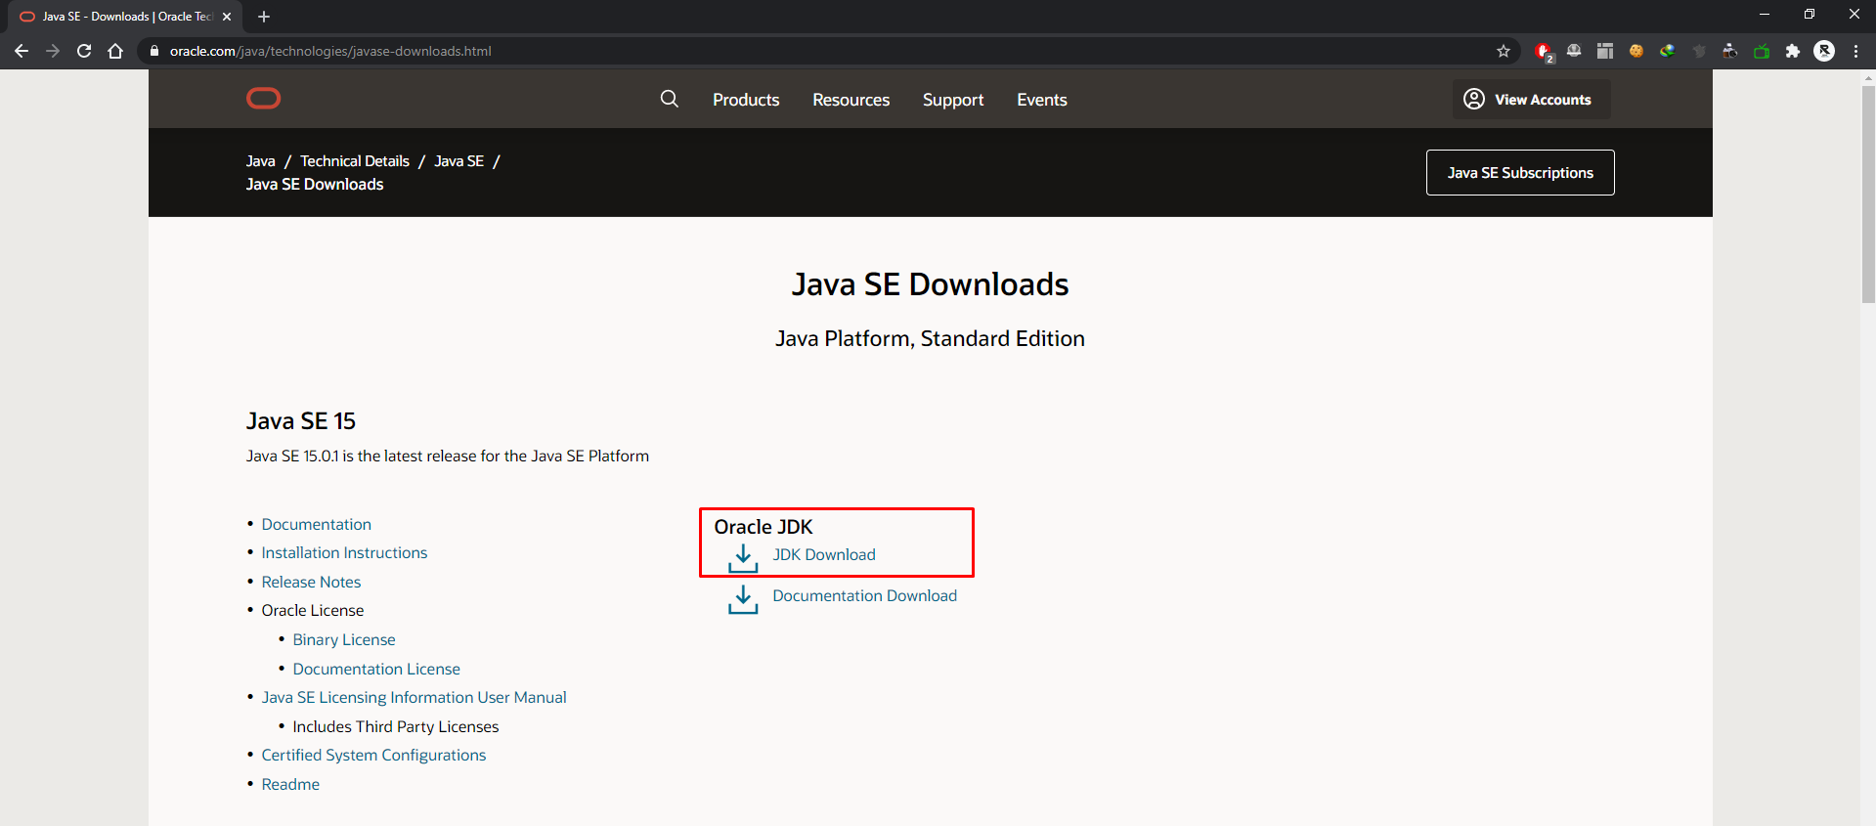

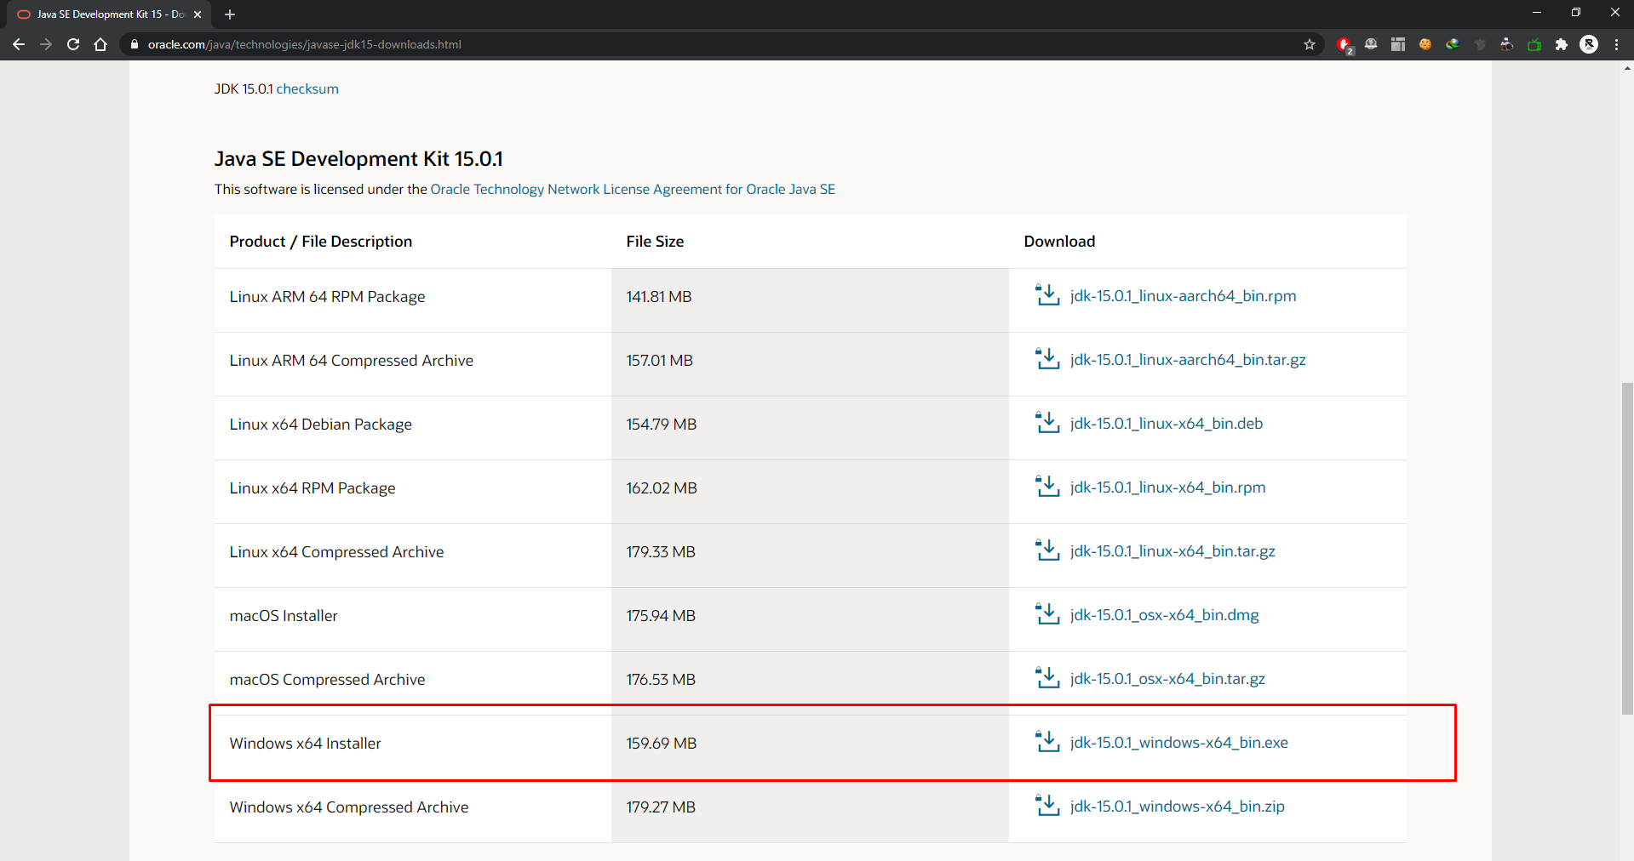

This JDK version comes bundled with Java Runtime Environment (JRE), so you do not need to download and install the JRE separately. Once installation is complete, open command prompt and type “java”. If you see the following screen you are good to move to the next step

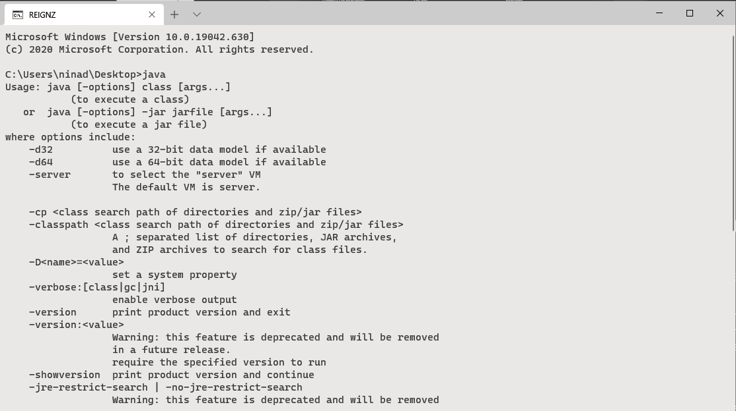

**Step 2: Install Eclipse IDE**

Download "Eclipse IDE for Java Developers" from http://www.eclipse.org/downloads/

Be sure to choose correctly between Windows 32 Bit and 64-Bit versions.

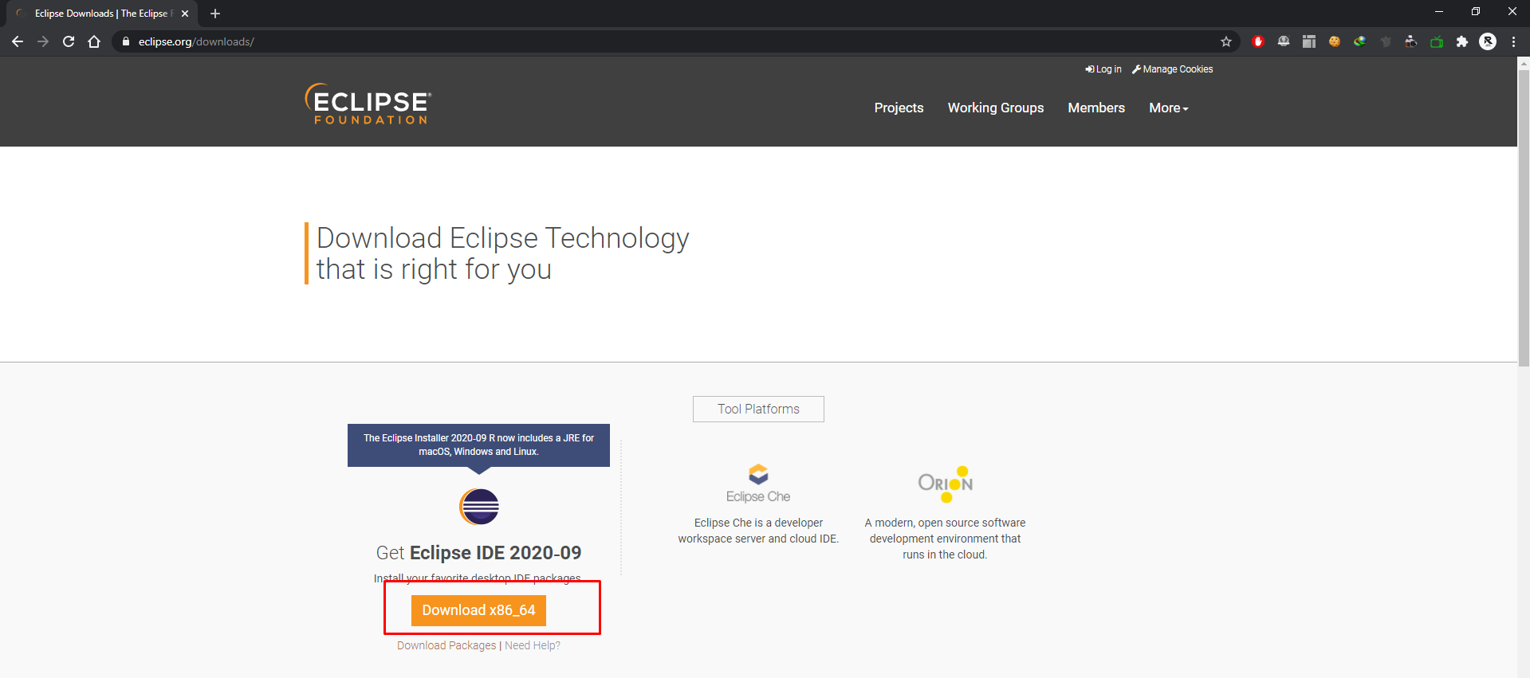

You should be able to download an exe file named "eclipse-inst-win64". Double-click on file to Install the Eclipse. A new window will open. Click Eclipse IDE for Java Developers.

[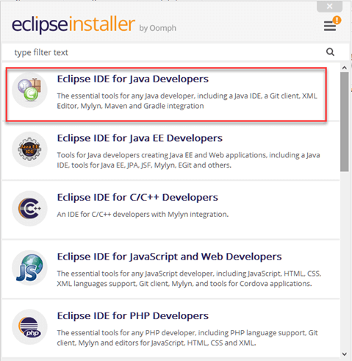](https://www.guru99.com/images/2-2017/022017_1205_Guidetoinst5.png)

After that, a new window will open which click button marked 1 and change path to "C:\eclipse". Post that Click on Install button marked 2.

[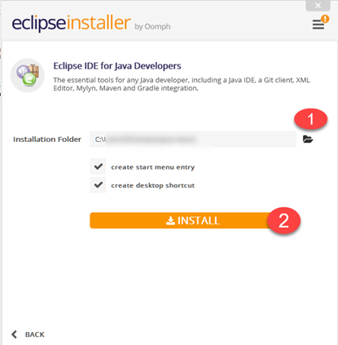](https://www.guru99.com/images/2-2017/022017_1205_Guidetoinst6.png)

After successful completion of the installation procedure, a window will appear. On that window click on Launch and it will start eclipse IDE for you.

[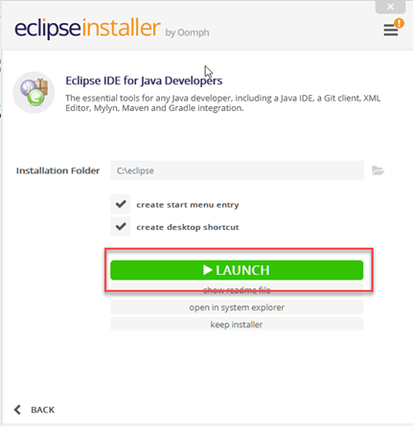](https://www.guru99.com/images/2-2017/022017_1205_Guidetoinst7.png)

**Step 3 - Download the Selenium Java Client Driver**

You can download the Selenium Java Client Driver from https://www.seleniumhq.org/

You will find client drivers for other languages there, but only choose the one for Java.

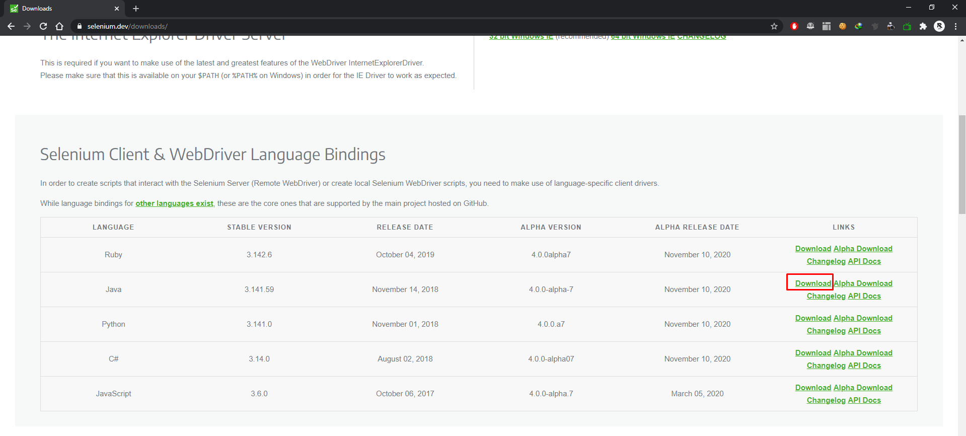

This download comes as a ZIP file named "selenium-java-3.141.59.zip". For simplicity, extract the contents of this ZIP file on your C drive so that you would have the directory "C:\selenium-java-3.141.59". This directory contains all the JAR files that we would later import on Eclipse.

**Step 4 - Configure Eclipse IDE with WebDriver**

1. Launch the "eclipse.exe" file inside the "eclipse" folder that we extracted in step.

2. If you followed step 2 correctly, the executable should be located on C:\eclipse\eclipse.exe.

3. When asked to select for a workspace, just accept the default location.

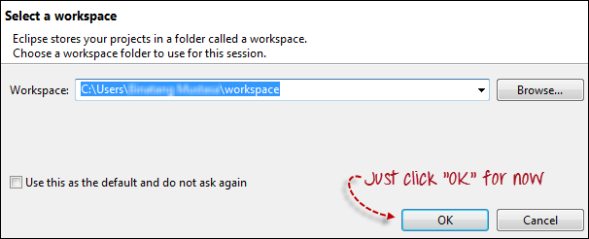

4. Create a new project through File > New > Java Project. Name the project as "newproject".

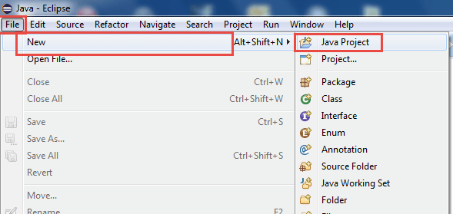

A new pop-up window will open enter details as follow :

i. Project Name

ii. Location to save project

iii. Select an execution JRE

iv. Select layout project option

v. Click on Finish button

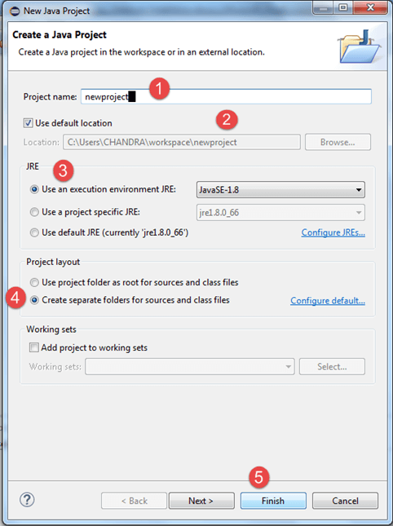

4. In this step,

i. Right-click on the newly created project and

ii. Select New > Package, and name that package as "newpackage".

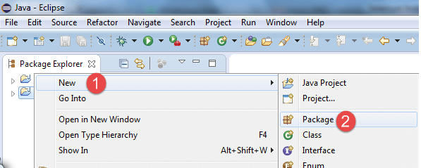

A pop-up window will open to name the package,

i. Enter the name of the package

ii. Click on Finish button

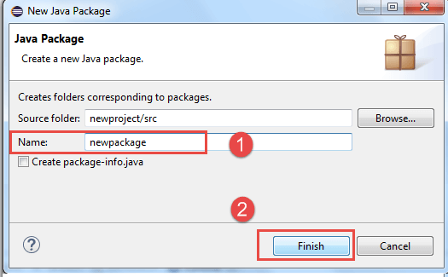

5. Create a new Java class under newpackage by right-clicking on it and then selecting- New > Class, and then name it as "MyClass". Your Eclipse IDE should look like the image below.

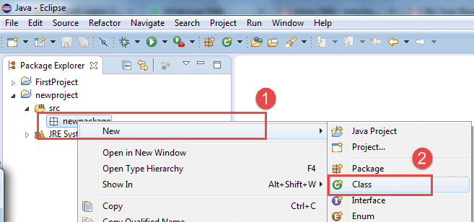

When you click on Class, a pop-up window will open, enter details as

i. Name of the class

ii. Click on Finish button

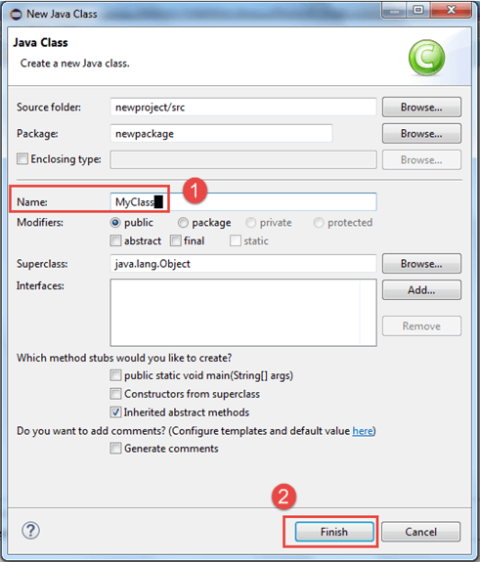

This is how it looks like after creating class.

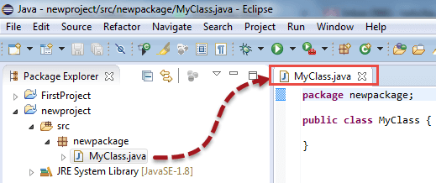

6. Now selenium WebDriver's into Java Build Path. In this step,

i. Right-click on "newproject" and select Properties.

ii. On the Properties dialog, click on "Java Build Path".

iii. Click on the Libraries tab, and then

iv. Click on "Add External JARs." in class path

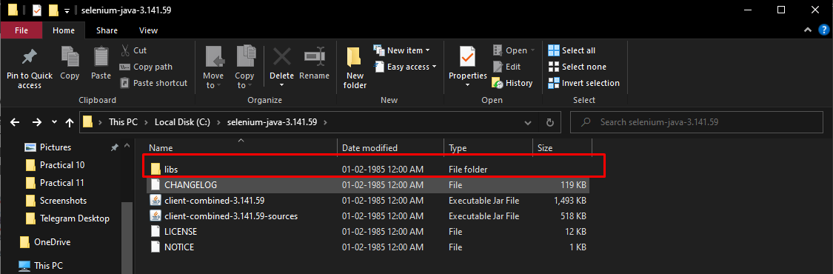

After selecting jar files, click on OK button. Select all files inside the lib folder.

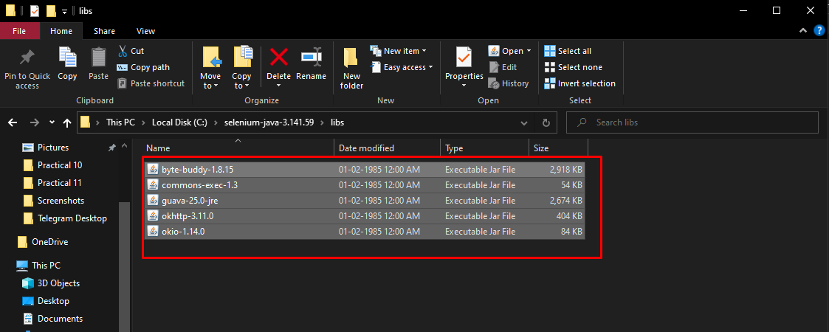

Select files outside lib folder

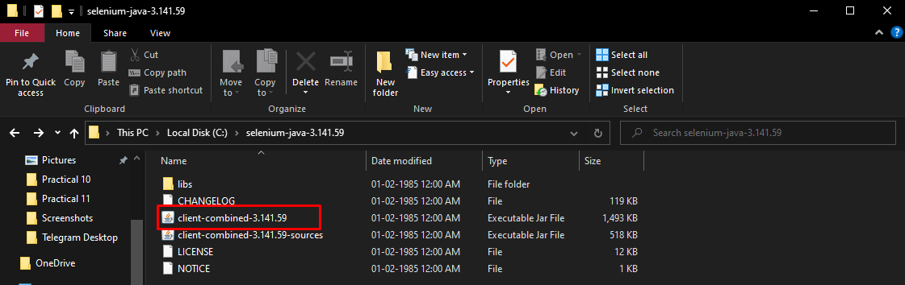

Add all the JAR files inside and outside the "libs" folder. Your Properties dialog should now look similar to the image below. Once done, click "Apply and Close" button

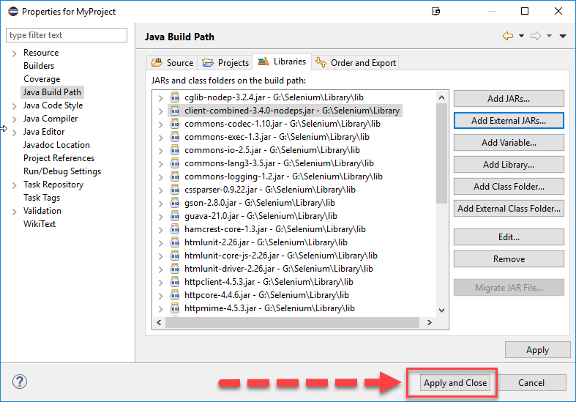

7. Finally, click OK and we are done importing Selenium libraries into our project.

**CODE**

**Program 1:** To Verify the Title of Omayo blogspot Home Page.

package selenium;

import org.openqa.selenium.WebDriver;

import org.openqa.selenium.chrome.ChromeDriver;

public class P1

{

public static void main(String[] args)

{

System.setProperty("webdriver.chrome.driver","E:\\MCA Data\\MCA\\SYMCA\\Practical\\STQA\\Practical 11\\chromedriver.exe");

WebDriver driver = new ChromeDriver();

String baseUrl = "https://omayo.blogspot.com/";

String expectedTitle = "omayo (QAFox.com)";

String actualTitle = "";

driver.get(baseUrl);

actualTitle = driver.getTitle();

if (actualTitle.contentEquals(expectedTitle))

{

System.out.println("Test Passed!");

}

else

{

System.out.println("Test Failed");

}

driver.close();

}

}

**OUTPUT**

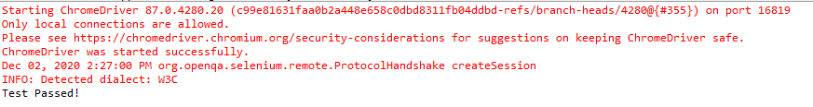

**CODE**

**Program 2:** Program to locate an element by ID

package selenium;

import org.openqa.selenium.By;

import org.openqa.selenium.WebDriver;

import org.openqa.selenium.chrome.ChromeDriver;

public class P2

{

public static void main(String[] args)

{

System.setProperty("webdriver.chrome.driver","E:\\MCA Data\\MCA\\SYMCA\\Practical\\STQA\\Practical 11\\chromedriver.exe");

WebDriver driver = new ChromeDriver();

String baseUrl = "http://www.facebook.com";

String tagName = "";

driver.get(baseUrl);

tagName = driver.findElement(By.id("email")).getTagName();

System.out.println(tagName);

driver.close();

System.exit(0);

}

}

**OUTPUT**

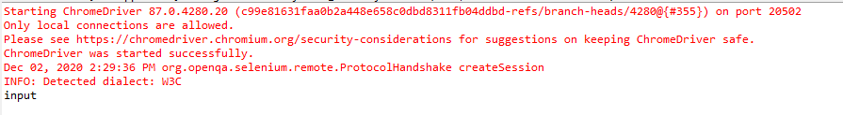

**CODE**

**Program 3:** Alert Message display

package selenium;

import org.openqa.selenium.By;

import org.openqa.selenium.WebDriver;

import org.openqa.selenium.chrome.ChromeDriver;

public class P3 {

public static void main(String[] args) {

System.*setProperty*("webdriver.chrome.driver","E:\\MCA Data\\MCA\\SYMCA\\Practical\\STQA\\Practical 11\\chromedriver.exe");

WebDriver driver = new ChromeDriver();

String alertMessage = "";

driver.get("http://jsbin.com/usidix/1");

driver.findElement(By.*cssSelector*("input[value=\"Go!\"]")).click();

alertMessage = driver.switchTo().alert().getText();

driver.switchTo().alert().accept();

System.*out*.println(alertMessage);

driver.quit();

}

}

**OUTPUT**

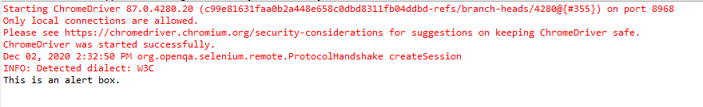

**Conclusion: We have performed the Test Automation using Selenium Web Drivers in Java.**